LAB TEST-2
H1:
Prompt to Cursor Ai:
Write Python code to extract @mentions and #hashtags from text. Input by user.
Use regex.
Ignore punctuation around tags.
Convert all to lowercase.
Return two lists and show sample tests.
Code by cusor:
import re
def extract_mentions_and_hashtags(text):
"""
Extract @mentions and #hashtags from text using regex.
Ignores punctuation around tags and converts all to lowercase.
Args:
text (str): Input text to extract mentions and hashtags from
Returns:
tuple: (mentions_list, hashtags_list) - two lists of extracted mentions and hashtags
"""
# Regex pattern for @mentions
# Matches @ followed by word characters, ignoring punctuation before/after
mention_pattern = r'@(\w+)'
# Regex pattern for #hashtags
# Matches # followed by word characters, ignoring punctuation before/after
hashtag_pattern = r'#(\w+)'

# Find all matches and convert to lowercase
mentions = [match.lower() for match in re.findall(mention_pattern, text)]
hashtags = [match.lower() for match in re.findall(hashtag_pattern, text)]
return mentions, hashtags
def get_user_input():
"""
Get text input from user for extraction
"""
print("\n" + "=" * 60)
print("User Input Section:")
print("=" * 60)
while True:
print("\nEnter your text (or 'quit' to exit):")
user_text = input("> ")
if user_text.lower() in ['quit', 'exit', 'q']:
print("Goodbye!")
break
if not user_text.strip():
print("Please enter some text!")
continue
mentions, hashtags = extract_mentions_and_hashtags(user_text)
print(f"\nResults:")
print(f"Mentions found: {mentions}")
print(f"Hashtags found: {hashtags}")
if mentions or hashtags:
print(f"\nSummary:")
if mentions:
print(f"- {len(mentions)} mention(s): {', '.join(mentions)}")
if hashtags:
print(f"- {len(hashtags)} hashtag(s): {', '.join(hashtags)}")
else:
print("- No mentions or hashtags found in the text.")

def main():
"""
Main function for user input extraction
"""
print("Extracting @mentions and #hashtags from text")
print("=" * 50)
# Get user input
get_user_input()
if __name__ == "__main__":
main()
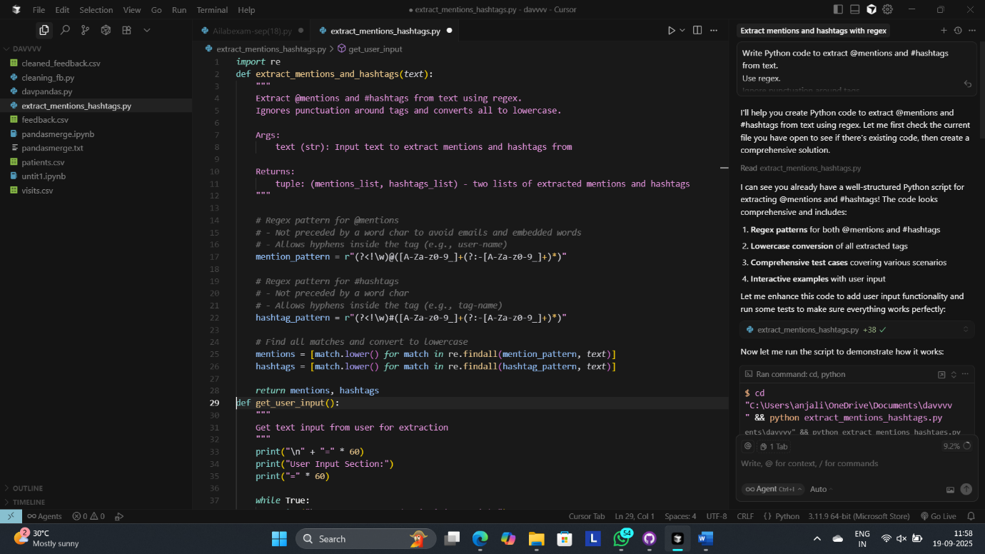
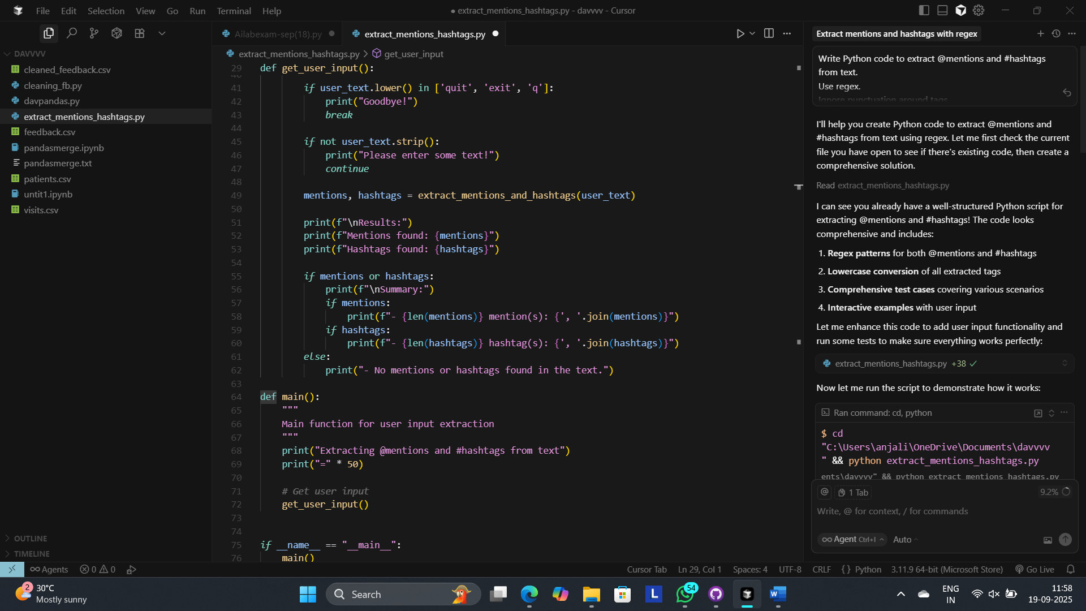

Output:
Sample input: Hello @alice check #AI and #Python with @Bob
Output: Enter your text (or 'quit' to exit):
> Hello @alice check #AI and #Python with @Bob
Results:
Mentions found: ['alice', 'bob']
Hashtags found: ['ai', 'python']
Summary:
- 2 mention(s): alice, bob
- 2 hashtag(s): ai, python
>Enter your text (or 'quit' to exit):
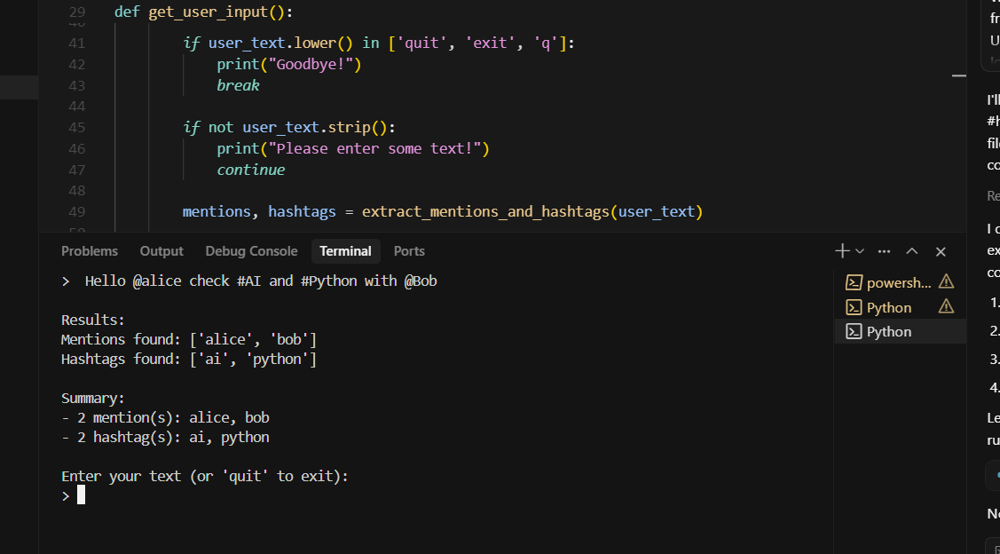
Explanation of code by cursor:
- Core Function: extract_mentions_and_hashtags(text)
- Uses regex patterns @(\w+) and #(\w+)
- Converts all results to lowercase
- Ignores punctuation around tags
- Returns two lists: mentions and hashtags

- User Input Function: get_user_input()
- Prompts user to enter text
- Processes the input and shows results
- Allows continuous input until user types 'quit'
- Shows summary of found mentions and hashtags

- Clean Output: Shows extracted mentions and hashtags in separate lists with counts

H2:
Prompt to cursor Ai:
Write Python code for Dijkstra using heapq.
Start from 'A'.
Return distances dict.
Also print each relaxation step and input is by user.
Code:
import heapq
from collections import defaultdict

def dijkstra_heapq(graph, start):
"""
Dijkstra's algorithm using heapq to find shortest distances from start node.

Args:
graph: Dictionary representing adjacency list {node: {neighbor: weight, ...}}
start: Starting node

Returns:
Dictionary of shortest distances from start to all nodes
"""
# Get all nodes from the graph
all_nodes = set(graph.keys())
for neighbors in graph.values():
all_nodes.update(neighbors.keys())

# Initialize distances dictionary
distances = {node: float('inf') for node in all_nodes}
distances[start] = 0

# Priority queue: (distance, node)
pq = [(0, start)]

# Set to keep track of visited nodes
visited = set()

print(f"Starting Dijkstra's algorithm from node '{start}'")
print(f"Initial distances: {distances}")
print("-" * 50)

step = 1

while pq:
# Get the node with minimum distance
current_dist, current_node = heapq.heappop(pq)

# Skip if already visited
if current_node in visited:
continue

visited.add(current_node)

print(f"Step {step}: Processing node '{current_node}' with distance {current_dist}")

# Explore all neighbors
if current_node in graph:
for neighbor, weight in graph[current_node].items():
if neighbor not in visited:
new_distance = current_dist + weight

print(f" Checking edge: {current_node} -> {neighbor} (weight: {weight})")
print(f" Current distance to {neighbor}: {distances[neighbor]}")
print(f" New distance via {current_node}: {new_distance}")

# Relaxation step
if new_distance < distances[neighbor]:
old_distance = distances[neighbor]
distances[neighbor] = new_distance
heapq.heappush(pq, (new_distance, neighbor))
print(f" ✓ RELAXATION: Updated distance to {neighbor}: {old_distance} -> {new_distance}")
else:
print(f" ✗ No relaxation: {new_distance} >= {distances[neighbor]}")

print()

print(f" Added {current_node} to visited set")
print(f" Current distances: {distances}")
print("-" * 50)
step += 1

print("Algorithm completed!")
print(f"Final distances from '{start}': {distances}")
return distances

def get_graph_from_user():
"""
Get graph input from user as a dictionary string.
"""
print("Enter the graph as a dictionary:")
print("Format: {'A': {'B': 1, 'C': 4}, 'B': {'C': 2, 'D': 5}, 'C': {'D': 1}, 'D': {}}")
print()

while True:
graph_input = input("Enter graph dictionary: ").strip()

if not graph_input:
print("Please enter a valid graph dictionary.")
continue

try:
# Use eval to parse the dictionary string
graph = eval(graph_input)

# Validate that it's a dictionary
if not isinstance(graph, dict):
print("Error: Input must be a dictionary.")
continue

# Validate that all values are dictionaries
for node, neighbors in graph.items():
if not isinstance(neighbors, dict):
print(f"Error: Node '{node}' must have a dictionary of neighbors.")
break
for neighbor, weight in neighbors.items():
if not isinstance(weight, (int, float)):
print(f"Error: Weight from '{node}' to '{neighbor}' must be a number.")
break
else:
print(f"Graph parsed successfully: {graph}")
return graph

except Exception as e:
print(f"Error parsing dictionary: {e}")
print("Please enter a valid dictionary format.")
continue

def run_demo():
"""
Run a demo with the provided sample graph.
"""
print("DEMO: Running Dijkstra's algorithm with sample graph")
print("=" * 60)

# Sample graph from user's request
sample_graph = {
'A': {'B': 1, 'C': 4},
'B': {'C': 2, 'D': 5},
'C': {'D': 1},
'D': {}
}

print(f"Sample graph: {sample_graph}")
print()

# Expected result
expected = {'A': 0, 'B': 1, 'C': 3, 'D': 4}
print(f"Expected result: {expected}")
print()

# Run algorithm
distances = dijkstra_heapq(sample_graph, 'A')

print("\n" + "=" * 60)
print("DEMO RESULTS:")
print("=" * 60)

for node, distance in sorted(distances.items()):
if distance == float('inf'):
print(f"Distance from A to {node}: ∞ (unreachable)")
else:
print(f"Distance from A to {node}: {distance}")

print(f"\nActual result: {distances}")
print(f"Expected result: {expected}")

# Check if results match
if distances == expected:
print("✅ SUCCESS: Results match expected output!")
else:
print("❌ Results do not match expected output.")

return distances

def main():
print("Dijkstra's Algorithm with heapq Implementation")
print("=" * 50)
print()

# Ask user what they want to do
choice = input("Choose an option:\n1. Run demo with sample graph\n2. Enter custom graph\nEnter choice (1 or 2): ").strip()

if choice == '1':
run_demo()
elif choice == '2':
# Get graph from user
graph = get_graph_from_user()

if not graph:
print("No graph entered. Exiting.")
return

print(f"\nGraph entered: {graph}")
print()

# Run Dijkstra's algorithm starting from 'A'
start_node = 'A'

if start_node not in graph:
print(f"Error: Starting node '{start_node}' not found in graph.")
print("Available nodes:", list(graph.keys()))
return

distances = dijkstra_heapq(graph, start_node)

print("\n" + "=" * 50)
print("FINAL RESULTS:")
print("=" * 50)

for node, distance in distances.items():
if distance == float('inf'):
print(f"Distance from {start_node} to {node}: ∞ (unreachable)")
else:
print(f"Distance from {start_node} to {node}: {distance}")
else:
print("Invalid choice. Please run the program again.")

def simple_main():
"""
Simplified version that directly asks for graph input.
"""
print("Dijkstra's Algorithm with heapq Implementation")
print("=" * 50)
print()

# Get graph from user directly
graph = get_graph_from_user()

if not graph:
print("No graph entered. Exiting.")
return

print(f"\nGraph entered: {graph}")
print()

# Run Dijkstra's algorithm starting from 'A'
start_node = 'A'

if start_node not in graph:
print(f"Error: Starting node '{start_node}' not found in graph.")
print("Available nodes:", list(graph.keys()))
return

distances = dijkstra_heapq(graph, start_node)

print("\n" + "=" * 50)
print("FINAL RESULTS:")
print("=" * 50)

for node, distance in distances.items():
if distance == float('inf'):
print(f"Distance from {start_node} to {node}: ∞ (unreachable)")
else:
print(f"Distance from {start_node} to {node}: {distance}")

return distances

if __name__ == "__main__":
run_demo()
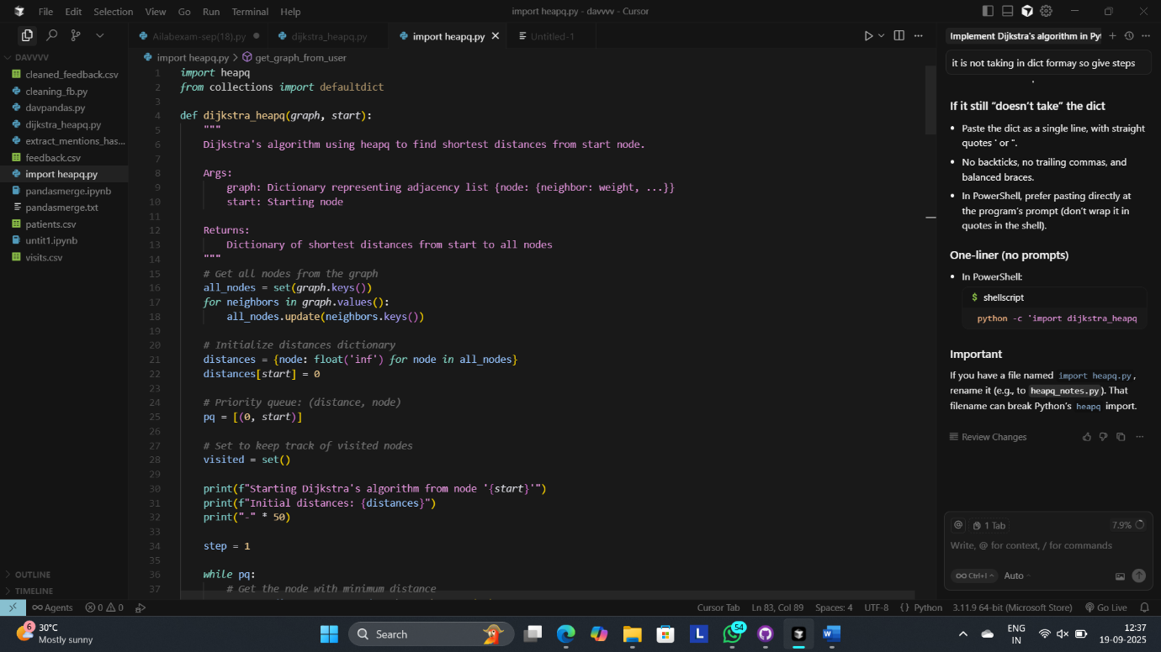
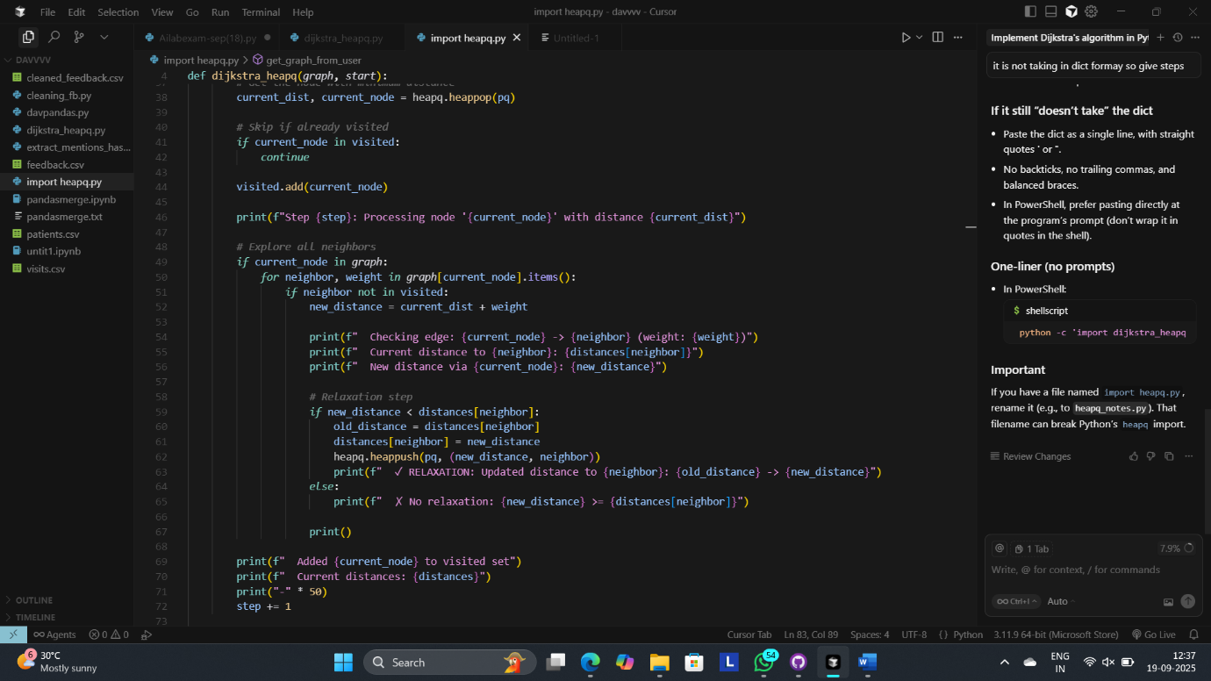
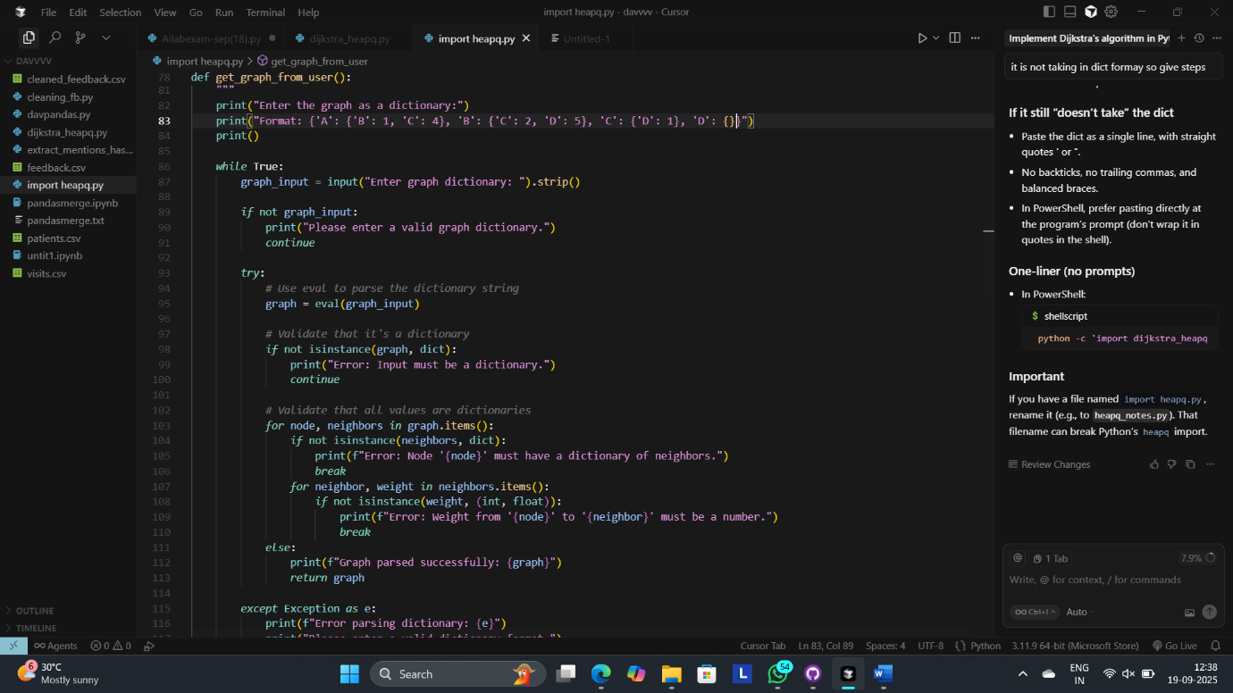
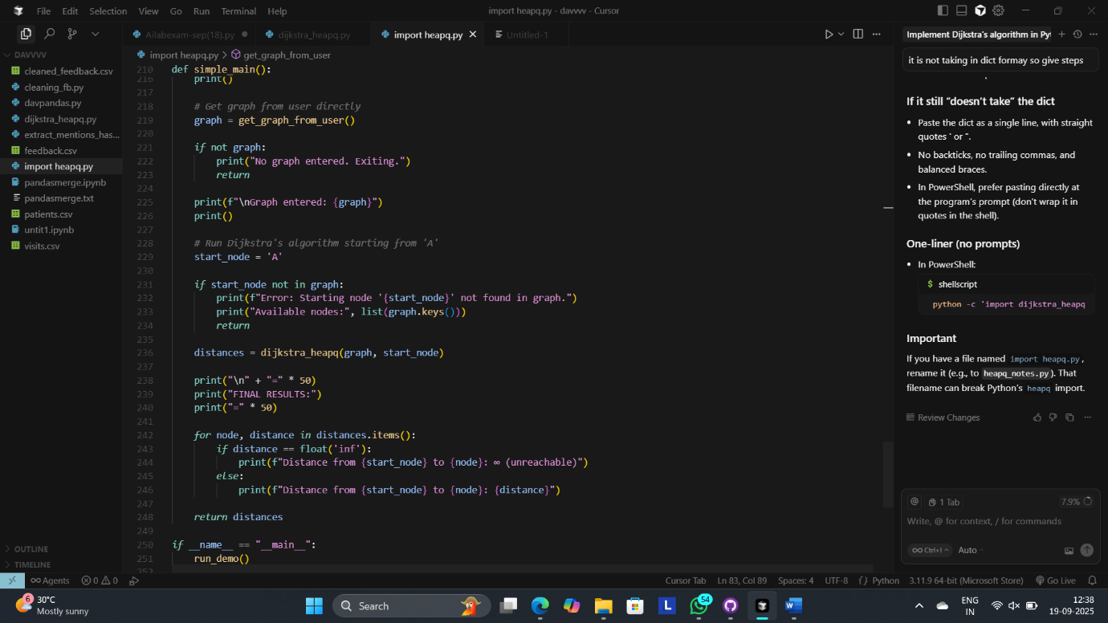

Output:
Step 1: Processing node 'A' with distance 0
Checking edge: A -> B (weight: 1)
Current distance to B: inf
New distance via A: 1
✓ RELAXATION: Updated distance to B: inf -> 1

Checking edge: A -> C (weight: 4)
Current distance to C: inf
New distance via A: 4
✓ RELAXATION: Updated distance to C: inf -> 4

Added A to visited set
Current distances: {'C': 4, 'B': 1, 'A': 0, 'D': inf}
--------------------------------------------------
Step 2: Processing node 'B' with distance 1
Checking edge: B -> C (weight: 2)
Current distance to C: 4
New distance via B: 3
✓ RELAXATION: Updated distance to C: 4 -> 3

Checking edge: B -> D (weight: 5)
Current distance to D: inf
New distance via B: 6
✓ RELAXATION: Updated distance to D: inf -> 6

Added B to visited set
Current distances: {'C': 3, 'B': 1, 'A': 0, 'D': 6}
--------------------------------------------------
Step 3: Processing node 'C' with distance 3
Checking edge: C -> D (weight: 1)
Current distance to D: 6
New distance via C: 4
✓ RELAXATION: Updated distance to D: 6 -> 4

Added C to visited set
Current distances: {'C': 3, 'B': 1, 'A': 0, 'D': 4}
--------------------------------------------------
Step 4: Processing node 'D' with distance 4
Added D to visited set
Current distances: {'C': 3, 'B': 1, 'A': 0, 'D': 4}
--------------------------------------------------
Algorithm completed!
Final distances from 'A': {'C': 3, 'B': 1, 'A': 0, 'D': 4}

============================================================
DEMO RESULTS:
============================================================
Distance from A to A: 0
Distance from A to B: 1
Distance from A to C: 3
Distance from A to D: 4

Actual result: {'C': 3, 'B': 1, 'A': 0, 'D': 4}
Expected result: {'A': 0, 'B': 1, 'C': 3, 'D': 4}
✅ SUCCESS: Results match expected output!
